Lab 1: The ArcMap Platform

Creating a Map

Geospatial Operations Support Team

(GOST)

Katie McWilliams

Benjamin Stewart

GOST@worldbank.org

**LAB ONE: The ArcMap Platform, Creating a Map**

*A Geographic Information System is a tool used for building, managing, analyzing, and displaying geographic data. A map created using a GIS contains layers, which are collections of related geographic data. Based upon the purpose of the map you are creating, you can choose what layers to add and display.*

***Vector layers*** *contain features, or geographic objects. For example, a layer of cities will contain different cities, or a layer of rivers will contain information on many different rivers. Geographic features can be presented in three ways- points, lines, or polygons. Points are generally used to represent small features on large maps, such as cities on a map of Europe. Lines are used to represent narrow features, such as rivers or highways. Polygons typically represent features with boundaries- such as countries or lakes. Data in point, line, or polygon form are collectively known as vector data.*

*Aside from vector data, layers in ArcMap can also come in raster format.* ***Raster layers*** *are not collections of geographic features, like vectors, but rather consist of continuous data (data that does not have a distinct ‘shape’- such as elevation, temperature, or rainfall). A raster is a matrix of cells, similar to the individual pixels in a digital photograph. Each cell represents a certain area on the ground, and contains the information for that location.*

**EXERCISE OBJECTIVES:**

1. Explore the ArcGIS platform
2. Identify basic tools and their functions
3. Learn layer symbology
4. Create a high-quality map for publication

**PART 1: Adding data, connecting to folders, basic tools and options.**

*Before creating a map, it is necessary to become familiar with ArcMap’s platform and layout. The following exercise will introduce you to some of the basic functions.*

|  |  |
| --- | --- |
| 1. Open ArcMap by double-clicking on the desktop icon. If there is no icon, you may need to navigate to the program using the Start menu. | S:\Administrative\GIS Training\Karachi GIS Training\Screenshots\ArcIcon.JPG |

1. When the dialog box appears, click on ‘New Maps’ on the left-side menu, and then choose ‘Blank Map.’ Click OK and a blank ArcMap document will open.

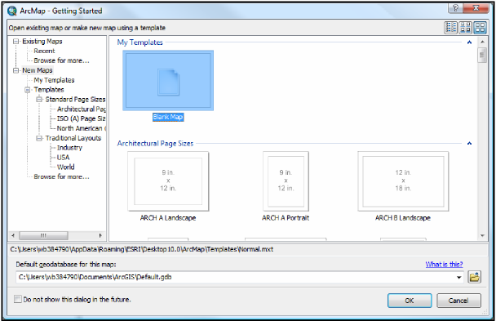

1. Adding data: towards the top of the screen, select the button that looks like a yellow square with a black plus sign (see red box below). This opens the add data dialogue box. You can also go to File > Add data.

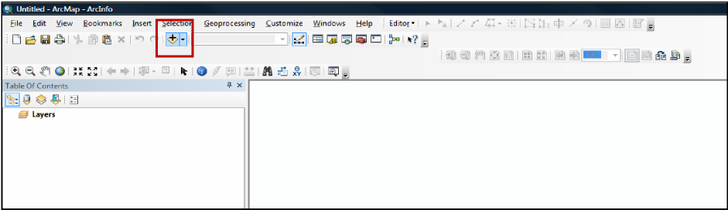

1. In the dialogue box that appears, use the drop-down menu to navigate to the desktop. If it does not appear, you may need to get ArcMap to recognize the drive by connecting to it.

5. To locate the desktop, click the ‘Connect To Folder’ button (a folder with a black plus (+) sign).

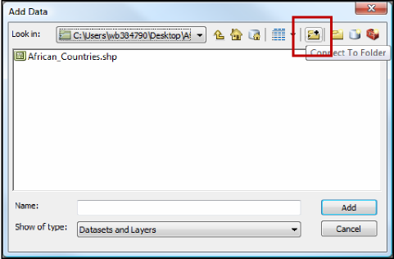

1. Choose the folder (desktop) to which you want to connect. (You will only need to connect to the drive once- after you establish this connection, ArcMap will automatically direct you to this location whenever you add data.) Click OK.
2. Now that it is connected, choose the Desktop from the dropdown menu. Double click on the ‘GIS Training’ folder, then open ‘Lab 1 Data.’
3. Inside the folder, you should see three files: **Countries.shp** (a polygon file), **Cities.shp** (a point file), and **Rivers.shp** (a line file). While holding down the Control key, click on each file until all three are highlighted. Then click ‘Add’ to add the three layer files to the map.
4. The layers for African countries, cities, and rivers should appear, centered in the display window. The layers will appear in the Table of Contents, which is on the left-hand side of the screen, under the ‘Layers’ column (see the orange box on the next page).

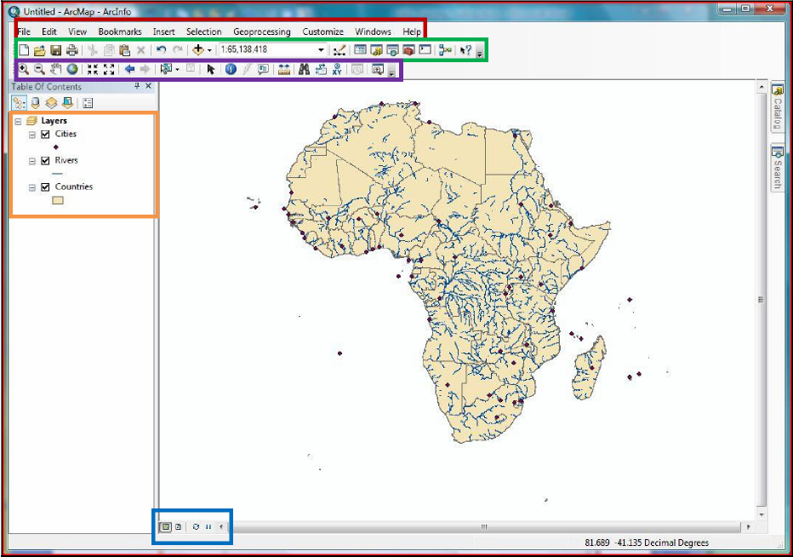

*NOTE: Arc will automatically place point files on top of the Table of Contents, then line files, then polygon files. Layers in ArcMap are presented on the display in the order that they are listed in the Table of Contents (i.e. the layer at the bottom of the list will appear below the other layers on the map). You may change the order of the layers at any time by clicking on a layer name and dragging it to a new position.*

*Also, note how the three boxes next to the layer names are checked. When layers are checked, they are visible in the map display. If you would like to keep a layer on the map, but hide it, simply uncheck the box.*

10. We will work with the individual layers later- first, let’s explore some of the basic tools and options that appear on the main ArcMap screen:

*Top menu options (red box above): file, edit, etc.*

*Bottom function buttons (blue box above): data view, layout/page view, refresh Standard toolbar (green box above): new map, save, print, add data, scale*

*Basic Toolbar: (purple box above): zoom in and out, pan, full extent, selection, ruler*

*NOTE: If the last two toolbars do not appear, go to Customize >Toolbars, and turn on ‘Standard’ and ‘Tools.’ Keep in mind that they may appear ‘floating’ on the screen, and not docked to the top or bottom of the display window. You can dock them by dragging them to an empty space beside the existing docked toolbars.*



11. Explore the various buttons on the basic toolbar (above). First, select the ‘Zoom In’ tool (+). You can either click on the map to zoom in slowly, or you can use the tool to zoom in to a specific area. With the ‘Zoom In’ tool selected, click and hold your mouse over South Africa. Drag the mouse down and to the right, drawing a rectangle that covers part of the country. Release the mouse, and the map will zoom in to the rectangle you selected.

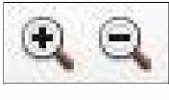

|  |  |
| --- | --- |
| 1. Now locate the ‘Fixed Zoom In’ and ‘Fixed Zoom Out’ buttons. Click on each one to observe how they change the visible area of the map. 2. The ‘Previous Extent’ and’ Next Extent’ buttons allow you to easily switch back and forth between the zoom changes you make (similar to ‘undo’ and ‘redo’ buttons for the scale). Click on each one a few times to see how ArcMap remembers the zoom changes you’ve made. 3. To remain at the same extent (the current zoom level) but see a different part of the map, click on the pan tool (it looks like a white hand). Click and hold as you move the mouse around to pan to a different area. 4. To return the map back to its regular size, click the button that looks like a globe- this is the “full extent” button. You can also use the ‘Zoom Out’ tool and click multiple times. |  |

|  |  |
| --- | --- |
| 1. To quickly identify certain features on the map, use the ‘Identify tool.’ Click on one of the dots on the map (representing a feature in the City layer). A box will appear that displays all of the associated information for the city you selected. Scan through the information, then close the box. |  |

**PART 2: The Attribute Table**

*Every layer file added to the display will have an associated table of information. This table is referred to as ‘the attribute table.’ In the previous steps (when you used the identify tool to pull up information about one of the cities), the data displayed in the identify box came from the attribute table. In this section we will explore the attribute table of one of the layers, and some of its functions.*

1. For this part of the exercise, we will only work with the **Countries** layer. Uncheck the boxes next to **Cities** and **Rivers** to hide them from the display. Then, right click on the **Countries** layer.
2. Click on ‘Open Attribute Table.’

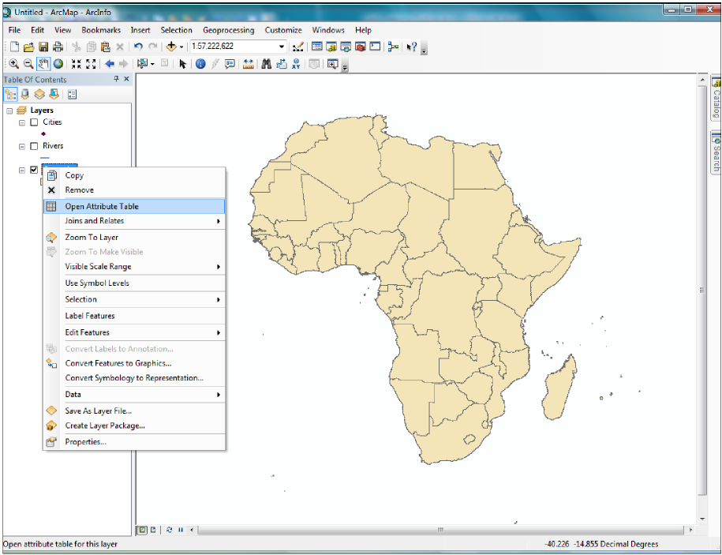

1. A table resembling a spreadsheet appears. The column headings across the top list the different fields of information- in this case; some of the notable fields include the English Name, the population in 2000, and its region.
2. Each row represents a different feature on the map- in this case, a different country. There are 58 rows, therefore there are 58 countries represented on the map.
3. Note how the countries are displayed alphabetically. To display the countries in reverse order, right- click on the ‘Name_English’ column heading and select ‘sort descending.’ You can sort and display any particular field- for example, to display the countries from smallest population to greatest, right- click on the ‘Pop2000’ field and click ‘sort ascending.’

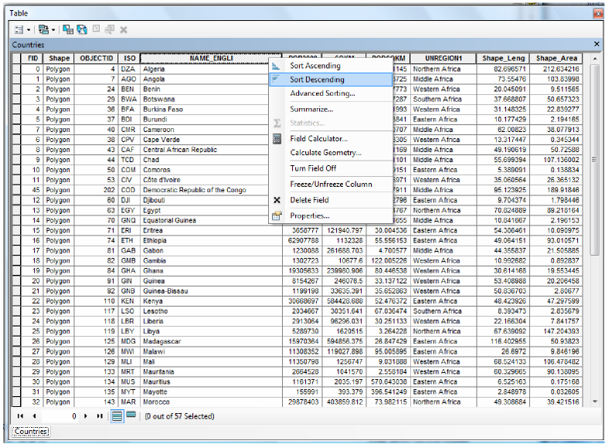

1. Highlighting certain rows/features in the attribute table will also highlight those features on the map. Say you want to identify where the most populous countries are in Africa- scroll down to the bottom of the attribute table (remember, your countries are now listed from smallest to greatest population).
2. At the far left-hand side of the attribute table, click in the empty grey box next to the very last feature- in this case, Nigeria.

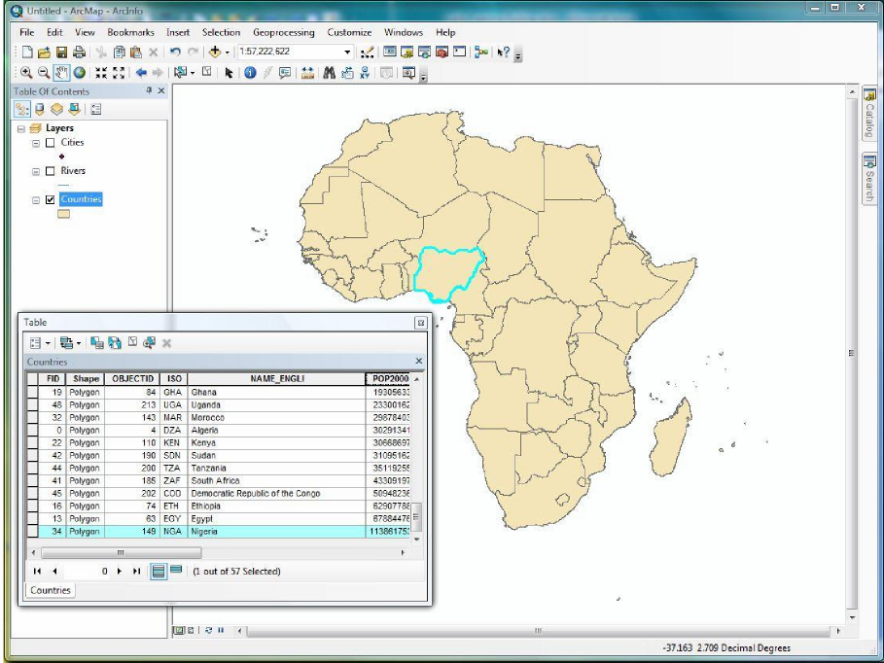

1. The whole row is now highlighted in a bright turquoise color. Drag the attribute table off to the side so you can see the map- and note how Nigeria is now outlined in the same color.
2. Now you’d like to see where the five most populous countries are. Click once again in the empty box to the left of the Nigerian row. Hold the mouse button down and drag up through the empty grey boxes, highlighting each row as you move up. Once five rows are highlighted, let go of the mouse button.

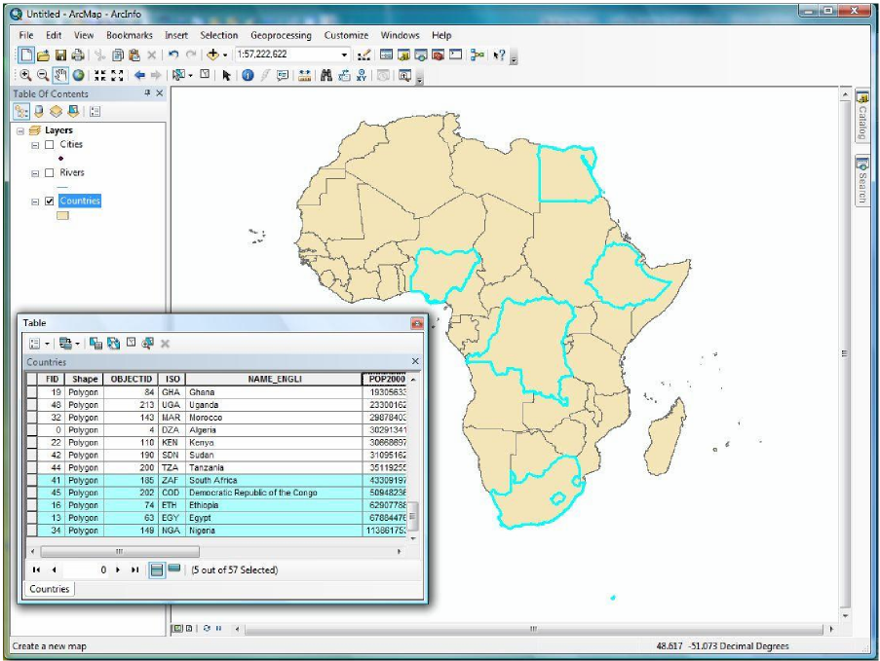

1. Move the attribute table and look at the map- the five most populous countries are now selected.

|  |  |
| --- | --- |
| 1. To clear the selected features, click the fifth icon from the left in the attribute table, called ‘Clear Selection’ (at right). This resets the table. |  |

1. Once you are familiar with the layout of the attribute table and selecting features, close out of it.

*Note: Selecting also works in reverse- you may select items directly on the map and see their attributes highlighted in the table.*

|  |  |
| --- | --- |
| 1. On the basic toolbar, click on the ‘direct selection’ tool. |  |

1. Click on any of the country polygons to select a single country.
2. Reopen the attribute table. The row of information belonging to the country you selected should be highlighted as well.

|  |  |
| --- | --- |
| 1. At the bottom of the attribute table, click ‘Show selected records.’ (Outlined in blue to the right.) This switches the table from displaying all of the countries, to displaying only the country you have selected. | C:\Users\wb374283\Desktop\Capture.JPG |

1. Clear the selection, and then close out of the attribute table. 

**PART 3: Exploring Layer Information and Properties, Data Sources, and Projections**

*Now that you are familiar with the attribute table, let’s look at some of the other layer properties.* 1. Right-click on the **Countries** layer in the Table of Contents to explore the layer options.

*Aside from opening the attribute table, from here you can remove the layer from the map, create a selection, zoom to the layer, label the features, and export some of the data to a new file.*

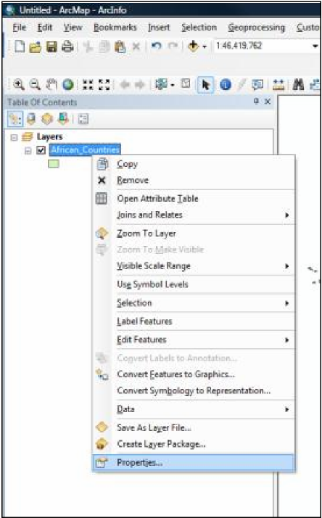2. For now, however, we are only going to look at the layer properties- move your mouse to the bottom of the list and click on properties.

1. A new dialogue box will open, with 11 information tabs. Click on the ‘source’ tab.
2. Listed here is all the information about the source of your layer file- the path to where the file is saved, the type of file (a polygon, since we’re looking at country boundaries), and finally the pertinent geographic information: the geographic and projected coordinate systems (if defined).
3. Note that the geographic coordinate system for this file is WGS_1984- a standard latitude/longitude coordinate system. There is no projected coordinate system listed, which means the file has never been projected. **A geographic coordinate system uses latitude and longitude to define the location of points on the surface of a sphere. A projected coordinate system, on the other hand, is a coordinate system that is used to project the 3D spherical earth onto a 2D flat surface. We will learn more above projections in Lab 2.**

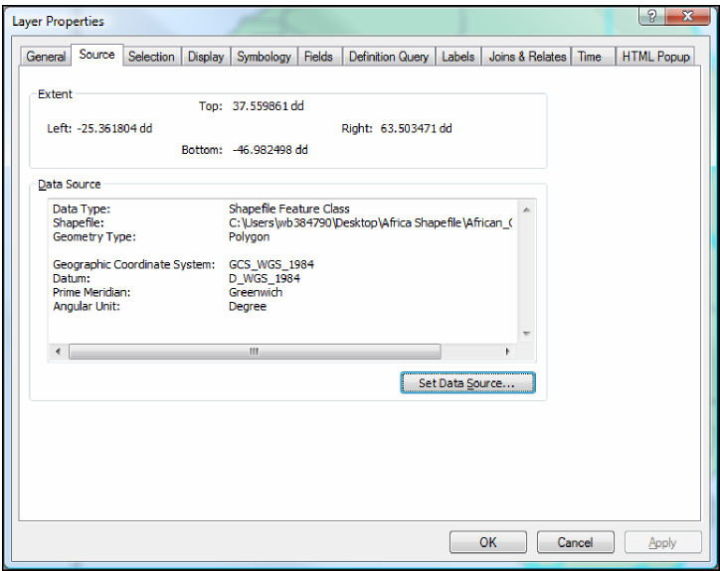

1. Explore some of the other tabs in the layer properties dialogue:

***General****: shows the layer name and description, and the scale at which the layer will be shown- the default option is set to ‘show layer at all scales.’*

***Selection****: where you can choose how a selected feature is displayed. The default is a bright turquoise outline.*

***Display****: among other options, this is where you can set transparency. This is helpful when you have two layers covering the same area and both need to be visible.*

***Symbology****: this tab contains all the different options for symbolizing the features displayed on the map. Here you decide which fields (columns of the attribute table) to display and how to display them, assign a classification and appropriate color ramp, and normalize data. We will come back to the symbology tab briefly at the end of this lab.*

***Labels****: if you want to label the features of this layer, this tab allows you to choose what field (i.e. column in the attribute table) will be used as labels, what the labels will look like, and where they are placed.*

**PART 4: Layer Symbology**

*The next part of this exercise is to use the information and tools you are familiar with to make a thematic map. There are different ways to symbolize points, lines, and polygons, so we’re going to go through basic symbology for each type of file.*

1. First, let’s use the symbol selector to explore different ways to display point files. Close out of the layer property dialogue, and then re-check the boxes next to the **Cities** and **Rivers** layers to turn them back on.
2. We’ll begin with the point file: click once on the colored dot below the **Cities** layer- this will open the basic symbology for the layer.

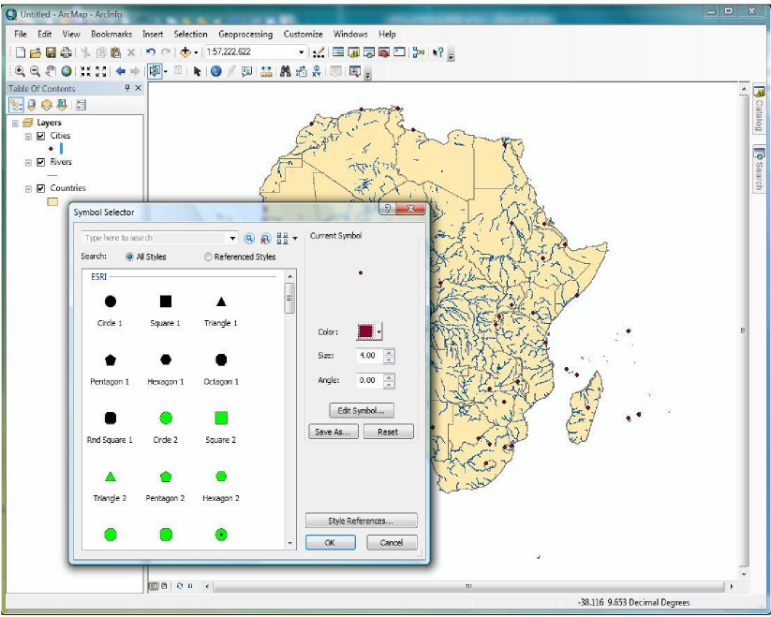

1. In the center are pre-saved default symbols. Scroll through the various options to see the differences. Click once on whichever symbol you would like to use to mark the cities. Your choice should appear in the upper right-hand corner ‘preview’ box.
2. In the options section, click on the ‘Color’ box to open the color options. Select any color you wish.
3. Below color, scroll up or down to adjust the size value.
4. If you chose a non-circular symbol, you can also adjust the angle.
5. Once you are satisfied with the shape, size, and color of your symbol, click ok.

*Note: ArcMap’s symbol selector automatically displays appropriate symbols based upon the type of file you are working with- either points, lines, polygons. The default options will change based upon the type of file you are working with.*

1. Repeat the symbol selecting process, except this time work with the **Rivers** layer.
2. After you open the symbol selector, note the differences in the pre-saved default options for line files versus point files.
3. Select an appropriate type of line (i.e. not one better suited for a highway). Also choose an appropriate color and width to display the rivers.

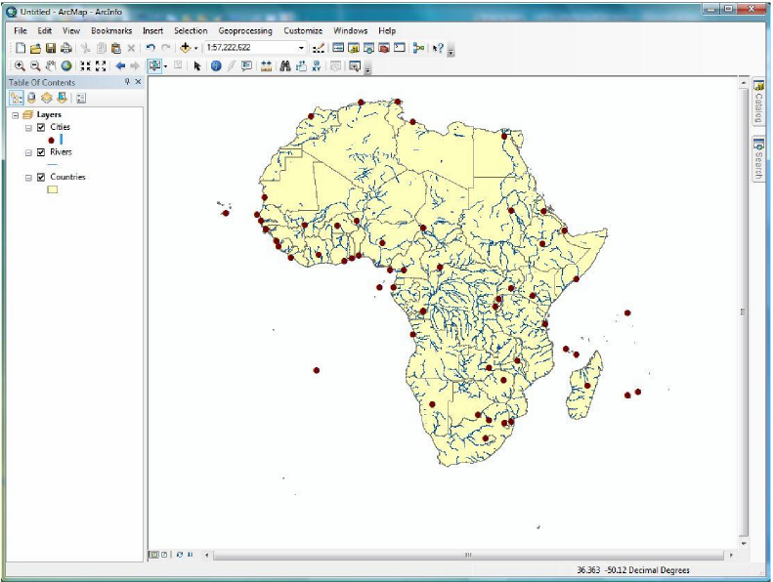

1. Finally, open the symbol selector for the **Countries** file, noting the default options for polygons. Adjust the fill and outline color of the country borders, then click OK.
2. Look at your map- do all three layers appear clearly? Or do your color and symbol options clash? If you need to, adjust the settings in one or more of your layers so your map is visually pleasing.

*Note: There are limitations to the symbol selector dialog- using this technique, all features in each layer must be displayed the same way (i.e. all cities must have the same symbol, or each country must have the same color fill). If you would like to assign different colors to individual features within the same layer, you must use the symbology tab under the properties menu (which we’ll do next).*

**TO SAVE: Since you have changed some of the settings, it’s time to save the map so you don’t lose your work. Go to File > Save As. Navigate to your Lab 1 folder and save the file as Map1.mxd.**

*Now let’s create a slightly more detailed map, using the symbology tab. The symbology tab gives you more choices and allows for more control when symbolizing features.*

1. First, turn off the **Rivers** layer, as we will only work with countries and cities for the rest of the exercise. Right-click on the **Countries** layer, and scroll down to properties. Select the symbology tab.
2. On the left-hand side of the symbology box (in the ‘Show’ area), note that the single-symbol features option is currently selected (which is the default), and that the color settings you chose in the last section are displayed in the center box.
3. Click the ‘Categories’ option in the ‘Show’ box on the left-hand side (red box on the next page). This option allows you to apply different symbols (or colors) for each different feature within one field of the attribute table.

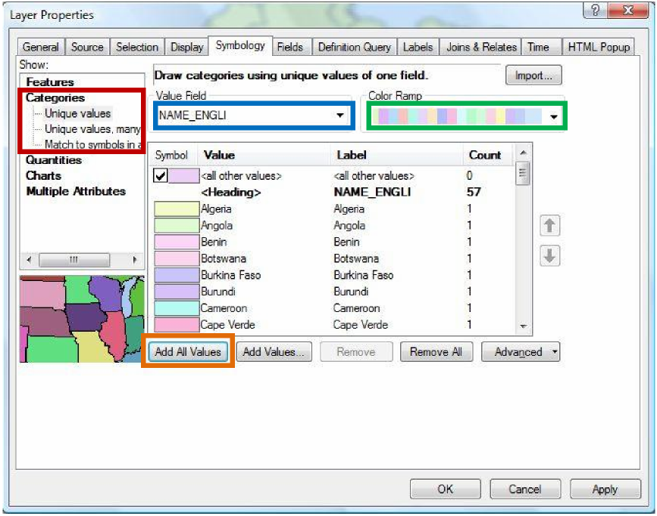

1. We are going to assign a different color to each different country. Select “Name_English” in the value field drop-down menu (see blue box above). Note that all of the fields in the attribute table appear in this menu.
2. Once you have selected “Name_English,” click on the “Add All Values” button (see orange box above). Note how the countries now appear in the center of the menu, with a different color next to their name. (Because we want to symbolize every country, we use the ‘Add All Values’ button. If you ever want to apply a symbology to only select features, use the ‘Add Values’ button. This will open a dialogue box that allows you to select only certain features to symbolize).
3. To change the colors, click the drop-down menu under ‘Color Ramp’ to explore your options (green box above). Select a color ramp that you feel suits the data. Remember that cities will also be displayed on the map, so don’t choose a color scheme that is overly bright or distracting.
4. Once you are satisfied with your color choices, click OK to return to the map.

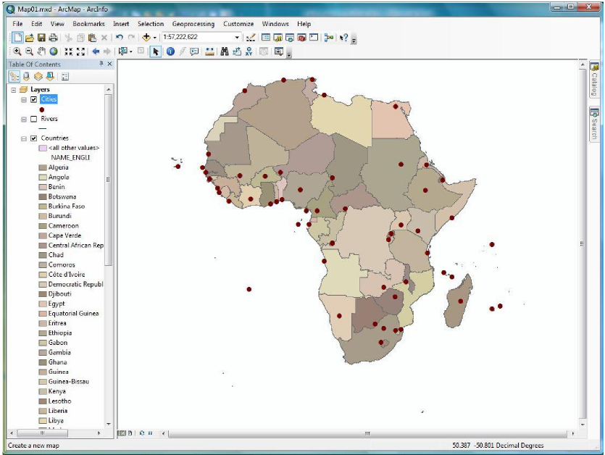

1. The final step for creating your map of Africa is to label the individual capital cities.

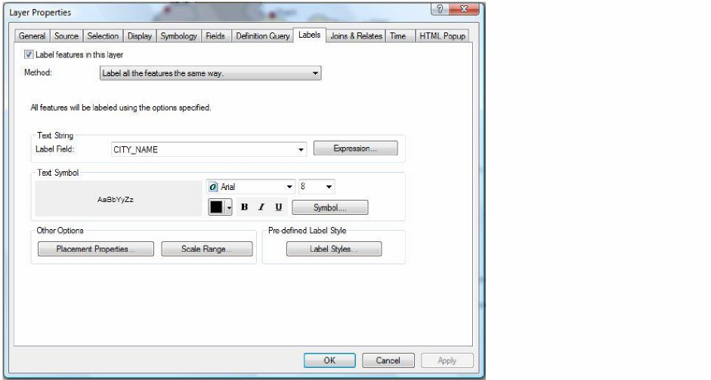

1. Right-click on the **Cities** layer and scroll down to ‘Label Features.’ The names of the cities should immediately appear on the map- although they may look small and some are too close together.
2. To adjust the font, sizes, and placement of the labels, return to the layer properties menu. (Right- click on the layer name and go to ‘Properties’).
3. Switch from the symbology to the labels tab.
4. The label field should be the ‘City_Name’ field. In the ‘Text Symbol’ box, you can change the font and text size. Adjust these until you are happy with the display (remember to keep the text size small so the labels do not appear too close together).
5. To adjust the location of the labels, click ‘Placement Properties’ (in the red box below), then select the ‘Conflict Detection’ tab.

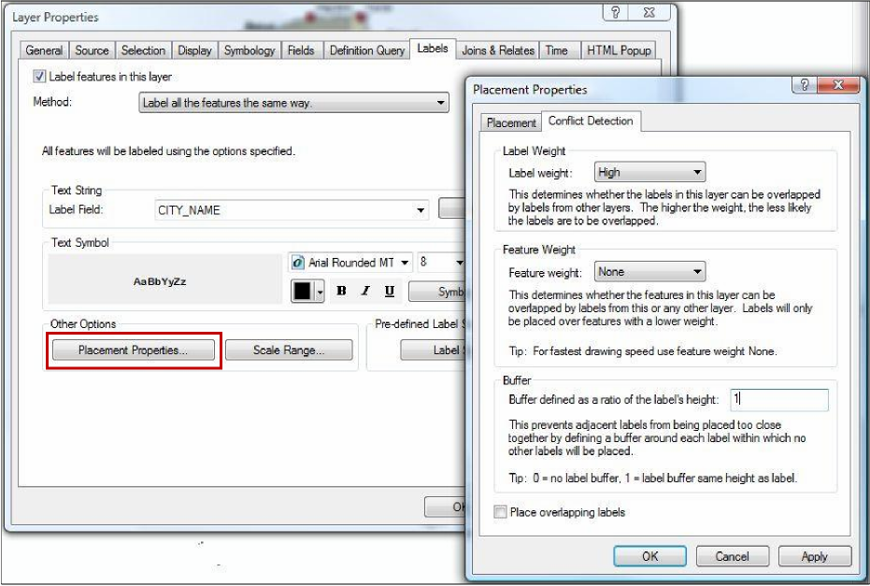

1. In the ‘Buffer option,’ type “1” into the value field- this will place a small buffer around each label so that none of the labels overlap or appear too close together.
2. Click OK twice to accept your changes and return to the map.

*Note: if your labels fail to draw (appear) on the map, click the ‘refresh’ button at the bottom-left of the main mapping window (it looks like two arrows that form a circle).*

28. Save your work.

**Part 5: Preparing for the Final Map/Print Layout**

*In this part of the lab exercise we will learn how to switch between the data view and layout view, as well as identify important skills for creating a final map to print.*

1. Up until now, you have been working in what is known as the data view. This view is good for analysis, but the layout view allows you to see what your final product will look like when preparing to print. We also add the cartographic elements necessary for all maps while in layout view.
2. Switch to the layout view by clicking on the second icon to the right of the bottom of the table of contents (in red below).

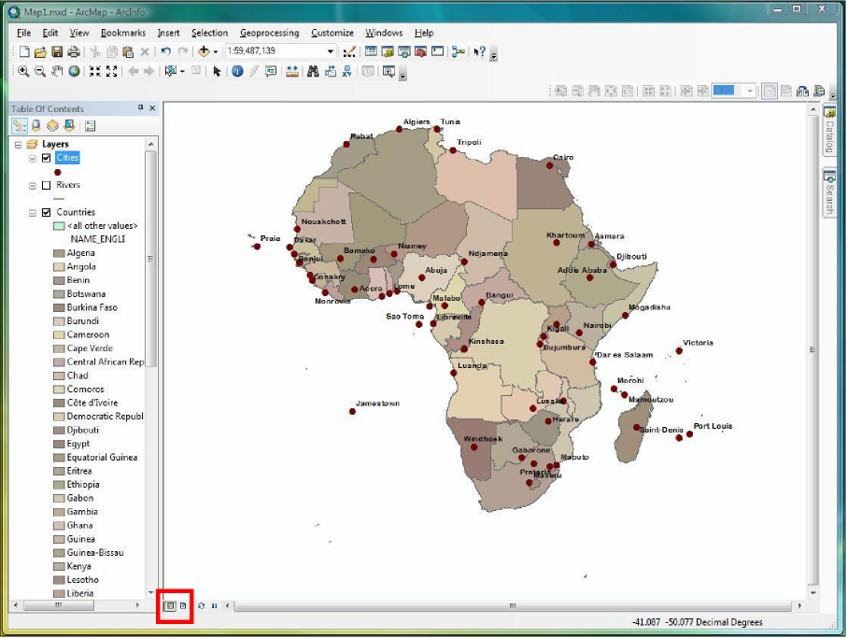

*You will now see the placement of your map in relation to the print page boundaries. The default layout is portrait, which is appropriate for displaying locations with a large North-South extent, such as Africa. (Should you ever need to switch to landscape view, go to File > Page and Print Setup. In the center of the dialogue box, you can switch the orientation from Portrait to Landscape.)*

*After panning around and zooming in and out in the data view during the lab, the map might be off- centered by the time you arrive to the layout view. An easy and visually appealing way to quickly center your map is by using the “Zoom to Layer” feature.*

1. Right click on the layer containing the outmost boundary of your map (this is usually the layer with the largest geographic extent- in this case, the best option is the **Countries** layer).
2. Select ‘Zoom to Layer.’ Now your map is centered on the layer you’ve selected, which is why it is important to perform this zoom on the outmost boundary.



*NOTE: When you switch into layout view, a new toolbar (shown above) appears above your map display: the layout tools. Here you will find zoom in, zoom out, pan, and other buttons that allow you to reconfigure how the whole display looks. Zooming and panning with this toolset is akin to moving the paper map closer to you, or farther away. If you use the regular toolbar zoom and pan tools while in layout mode, it will simply adjust the scale of the geography content, within the layout itself. Experiment with these tools and notice the difference between the zoom and pan function of the layout tools and the data tools.*

*With our map centered on the page, the next step is to insert the cartographic elements that are necessary for all maps. They include:*

***Legend****: A key to understanding the symbols or other information that appears on the map.* ***North Arrow****: An arrow that depicts the direction of North, to give the map directional context.*

***Scale bar****: A measurement that shows how the distance on the map relates to actual distance on the ground.*

***Title****: a short summary of the information displayed.*

|  |  |  |
| --- | --- | --- |
| 1. Click on “Insert” in the top menu bar. All of the necessary cartographic elements that are needed on the layout can be found in this menu. |  | 19 |

6. First, insert a border by choosing ‘Neatline’ under the Insert menu. In the dialogue box that opens, make sure the default ‘place around selected elements’ is highlighted. This will place the neatline around your entire layout.

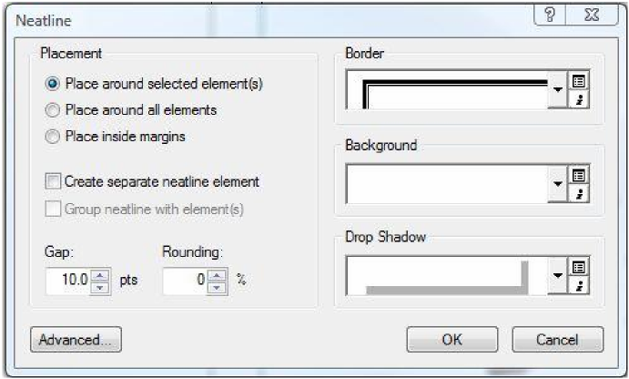

1. In the right drop-down menu under ‘Border,’ select a border that you feel is appropriate. If you’d like to add a background color or a drop shadow from their drop-down menus, you may select them here. Click OK.
2. Next, go to Insert > Legend. In the legend wizard box, you can select which of the map layers will appear in the legend. For this map, since we have plotted the location of the capital cities of African countries, the **Cities** layer is really the only one that needs to appear in the legend. We do not need a listing of every African country, so the **Countries** layer can be excluded. Use the arrows in the center of the screen to move the layers back and forth from the Layer column to the Legend Items column.

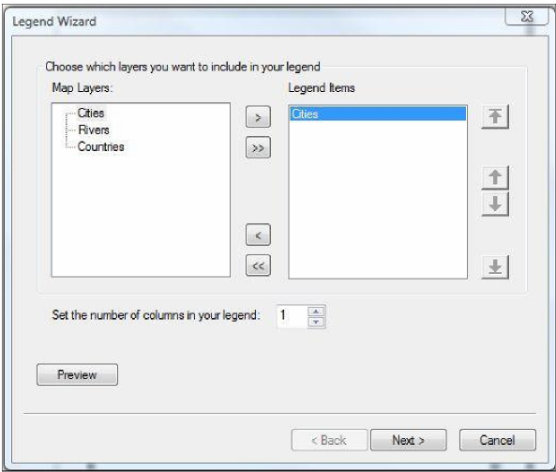

1. Click next. On the following screen, select the font style and title for the legend.
2. Continue through the wizard by selecting a border (and a background and drop shadow if you wish). Click next to pass through the remaining two screens, and finally click OK. Your legend should appear on the map. Click and drag it until it is positioned in an empty space on the layout. (If you are unhappy with the legend or want to adjust some of the settings, right-click on the legend and re­open the properties dialogue box).

*Your legend should display the symbol and name for the* ***Cities*** *layer. This information is linked- if you change the symbology, or the name of the layer, the change will be reflected in the legend.*

1. Now, go to Insert > North Arrow. Select whichever of the North Arrows you like, then click OK.
2. Go to Insert > Scale Bar, and select any bar you wish. Once it appears on the layout, drag it to a blank area where you can read the scale. Note that “Decimal Degrees” have appeared as the default unit. To change this to something more appropriate, right-click on the scale bar and select ‘properties.’

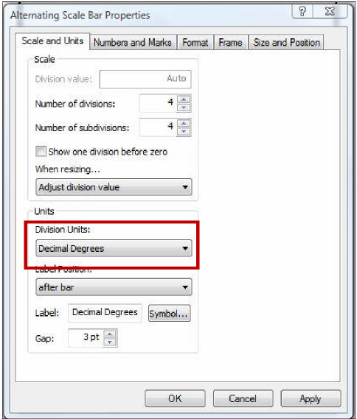

1. In the scale bar properties dialogue box, locate the drop-down box labeled “Division Units” (outlined in red above). Change the units to Kilometers.

14. Click ‘Apply’ and then OK.

1. The scale bar on the layout should now display Kilometers.

22

1. Now, using those guides, drag your various elements (Legend, North Arrow, and Scale Bar) until they align with the guides. Notice that when your objects get close to the guides, their edges should snap into position.

automatically “snap” to the guides to help with your alignment. Your layout will look something like

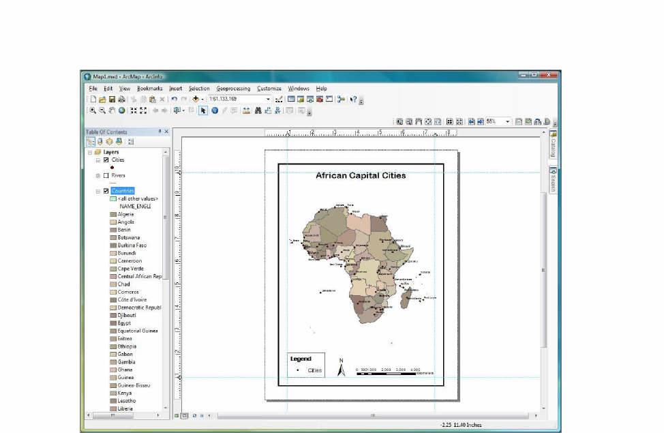

1. Lastly, insert a Title by going to Insert >Title. Remember, it’s best to not use the word “Map” here, as this is redundant- most people already know that they are looking at a map. Since we have labeled the cities and placed them in the legend, a suitable title is something such as “Capital Cities of Africa.” Your title should reflect the most important features or data outlined on the map.
2. Once the Title appears, double-click on it to open the Properties. If you’d like to change the font or size, click on ‘Change Symbol.’ This will open the symbol selector dialogue box. Remember, the title should be the biggest font on your screen- bigger than the text in the Legend or the labels on the map. But don’t make it so large that it dominates the layout.

*You have now added all pertinent cartographic details to your map- the final step is to reorganize the layout and make sure that all lines and text appear neat and organized. To do so, we will use the layout rulers and guides.*

|  |  |
| --- | --- |
| 1. In the ruler that runs along the top of the layout, click near the 1 inch mark- notice the blue line that appears straight down the map. This is called a guide- it helps you align the features on your map, and will not appear in the final print version. |  |

1. Create guides that are 1 inch inside of each of the four corners of your map, using both rulers.
2. Once you are happy with the position of your elements, you can remove the guides. Right click on each ruler, and select “Clear All Guides.”
3. File > Save to save your completed map.

*Aside from saving in the Arc format (.mxd), you may also export your map to formats compatible with other programs- such as PDF, JPEG, or TIFF.*

1. To export your map to JPEG go to File > Export Map. Navigate to where you would like to save the new file, and change the “Save as Type” drop-down menu to JPEG.
2. 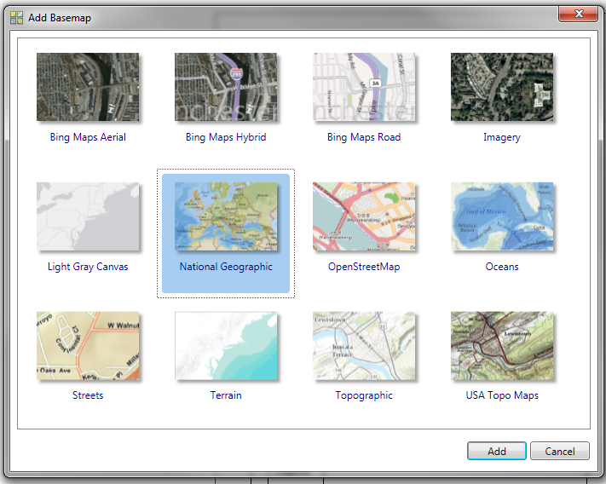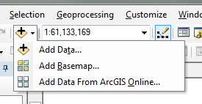**Extra credit** – If you have extra time, explore some of the basemaps that ESRI offers in Arcmap 10.x. Click on the add data button, where you see the triangle, so more options appear. Select ‘Add Basemap…’
3. Once you have chosen a basemap, go back and play with the symbology of your layers. Adjust the transparency so the data so it complements the basemap.

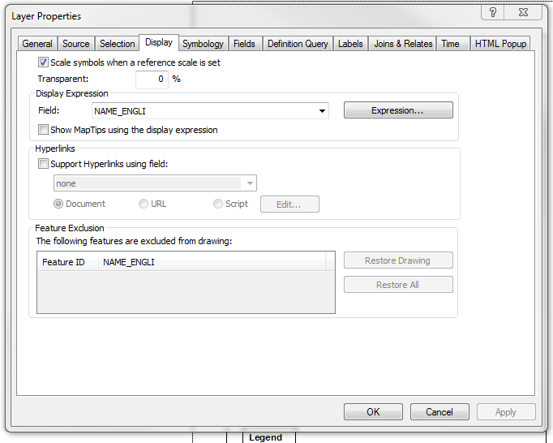

*Have even more time? Go back to ‘add data’ but instead of adding a basemap, try ‘Add Data from ArcGIS Online’*

*Congratulations, you have now completed the first lab exercise!*